FINANCIAL TRANSACTION
AND LOANS DASHBOARD
POWER BI PROJECT REPORT

Project Report Submitted By
ANUSHIYA.K

Introduction
This project presents a Financial Transaction and Loans Dashboard developed in Microsoft Power BI. It brings transaction, account, customer and loan information together in an interactive report. The dashboard uses KPI cards and charts to help users explore transaction activity, account types, loan status and transaction types from different perspectives.
Instead of reviewing records one by one, users can compare the information visually and apply filters to focus on a particular year, transaction type or account type. The report includes a separate tooltip page that provides additional information when a relevant visual is explored.

Objectives
- Present key financial transaction and loan indicators in one dashboard.
- Compare the number of accounts across account types.
- Track the number of transactions across months.
- Examine the distribution of loans by loan status.
- Compare transaction counts across transaction types.
- Show transaction counts and transaction values in a detailed table.
- Support interactive analysis through Year, Transaction Type and Account Type filters.

Dataset Description
The Power BI report is organized around information from transactions, accounts, customers and loans. The visible model fields and measures indicate that the dashboard is designed to summarize the activity of these related areas.
Data area / field | Meaning | Use in the dashboard
Transactions | Records of financial transactions | Monthly trend, transaction counts and total transaction value
Transaction types – TypeName | Transaction category/name | Comparison chart and detailed transaction table
Transaction types – TransactionTypeID | Transaction type identifier | Transaction Type slicer
Accounts | Account records and account measures | Account-type chart and Active Accounts KPI
Account types – TypeName | Account category/name | Comparison of total accounts by type
Account types – AccountTypeID | Account type identifier | Account Type slicer
Loans / StatusName | Loan records and loan status | Loan-status pie chart and total loans measure
Customers | Customer records | Total Customers KPI
Transactions – YEAR / TransactionDate | Year and date information | Year filter and monthly transaction trend

The report uses the model fields and measures already present in the supplied Power BI file. The underlying dataset values are not reproduced here unless they are directly visible from the report definition.

Data Preparation
The financial transaction dataset was loaded into Power BI Desktop and arranged for analysis using its transaction, account, customer and loan fields. The report layout separates headline indicators from detailed comparisons so that users can move from a general view to a more specific view.
- Numerical measures are used to summarize account, transaction, customer and loan information.
- Category fields such as TypeName and StatusName are used to group the records in charts.
- Transaction date information is used to display the monthly transaction trend.
- Year, Transaction Type and Account Type slicers allow users to filter the dashboard.
- A tooltip page is included to show extra transaction information when a visual is explored.

Measures and Calculations Used
Measure | Purpose
Active Loans | Displays the number of active loans represented by the current filter selection.
Active Accounts | Displays the number of active accounts represented by the current filter selection.
Total Customers | Shows the customer count represented in the dashboard.
Total transaction value | Summarizes the transaction value for the selected records.
Total accounts | Counts or summarizes accounts for comparison by account type.
Total transactions | Summarizes transaction counts for monthly and transaction-type visuals.
Total loans | Summarizes loans for the loan-status chart.

These measures respond to the available filters. The displayed result can therefore change when a user selects a different year, transaction type or account type.

Dashboard Overview
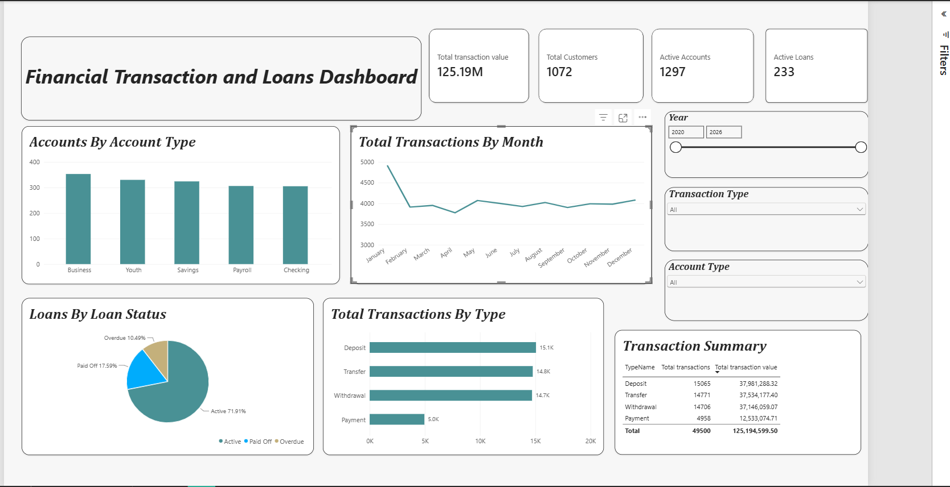
The main page is titled “Financial Transaction and Loans Dashboard.” It combines four KPI cards with charts and a detailed table. The cards highlight Active Loans, Active Accounts, Total Customers and Total Transaction Value. The lower visuals compare account types, monthly transaction activity, loan statuses and transaction types.

Main Dashboard Components
Component | Information shown | Why it is useful
KPI cards | Active Loans, Active Accounts, Total Customers and Total transaction value | Provides a quick summary of the selected data.
Column chart | Total accounts by account type | Compares the size of different account groups.
Line chart | Total transactions by month | Shows how transaction activity changes over time.
Pie chart | Total loans by loan status | Shows the relative distribution of loans by status.
Bar chart | Total transactions by transaction type | Makes transaction categories easy to compare.
Detailed table | Transaction type, total transactions and total transaction value | Allows side-by-side comparison of count and value.

The supplied Power BI definition confirms these visual types and fields. Exact KPI totals are not stated in this report because the file’s report definition does not expose the rendered values.

Account and Loan Analysis

Accounts by Type
The clustered column chart compares total accounts across the account types available in the dataset. Each column represents an account type, while the height indicates the total accounts associated with it. This makes it easier to identify which account groups have comparatively more or fewer accounts under the current filters.

Loans by Status
The pie chart groups loans by StatusName and uses Total Loans as its measure. It provides a visual summary of the loan-status distribution. Users can compare the visible portions of the chart to understand how loans are divided among the statuses included in the data.

KPI Cards
Active Accounts and Active Loans provide focused indicators of account and loan activity. The Total Customers card adds a customer-level view, while Total Transaction Value summarizes the value of transactions. These cards are intended to be read together with the charts rather than as isolated figures.

Transaction Analysis

Transactions by Month
The line chart shows Total Transactions across the months derived from TransactionDate. A line chart is suitable for identifying changes over time, including months with relatively higher or lower activity. It can help users decide which periods may need closer examination.

Transactions by Type
The horizontal bar chart compares Total Transactions across the available transaction types. Longer bars represent higher transaction counts within the selected filter context. This gives users a direct way to compare how frequently each transaction type appears.

Transaction Summary Table
The detailed table contains TypeName, Total Transactions and Total Transaction Value. It places transaction frequency and transaction value side by side, allowing users to compare categories using two different measures. The table complements the charts by presenting the information in a structured form.

Tooltip Page
A separate page named “Tooltip” is included in the report. It contains a transaction-value card, a transaction-type label and a total-transactions card. This tooltip page is intended to provide a compact detail view while the user explores the main dashboard.

Interactivity and Key Findings

Interactive Controls
Control | Function
Year | Filters the report by the selected year or date range.
Transaction Type | Filters the report to a selected transaction type.
Account Type | Filters the report to a selected account type.

The filters allow the user to focus on a smaller part of the dataset. As the selection changes, the measures and visuals can update to reflect the selected context.

Key Findings from the Dashboard Design
- The report brings transaction, account, customer and loan indicators into one view.
- Account types can be compared using the total-accounts column chart.
- The monthly line chart is designed to show changes in transaction activity over time.
- Loan status is summarized through a pie chart based on total loans.
- Transaction types can be compared by transaction count and transaction value.
- The Year, Transaction Type and Account Type controls support interactive exploration.
These findings describe what the dashboard is structured to analyze. Actual rankings or highest/lowest values should be confirmed from the live dashboard after opening the PBIX file.

Conclusion
The Financial Transaction and Loans Dashboard converts related financial records into an interactive Power BI report. Its KPI cards summarize important indicators, while the account-type, monthly transaction, loan-status and transaction-type visuals support comparison across different parts of the dataset.
The detailed transaction table and tooltip page provide additional ways to inspect the information. Together with the Year, Transaction Type and Account Type filters, these features make the dashboard useful for exploring transaction activity, accounts, customers and loans. The report demonstrates how Power BI can present financial data in a clear and structured visual format.

Dashboard Summary
Area | Summary
Overall indicators | Active Loans, Active Accounts, Total Customers and Total Transaction Value
Account analysis | Total accounts compared by account type
Transaction trend | Total transactions shown by month
Loan analysis | Total loans grouped by loan status
Transaction categories | Total transactions compared by transaction type
Detailed review | Transaction type, transaction count and transaction value in a table
Interactivity | Year, Transaction Type and Account Type filters

